Class Information Spring Term 2023
A Community Developing Happy, Confident, Caring, Children with a Positive Attitude to Life and Learning.

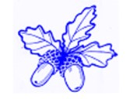

 |  | 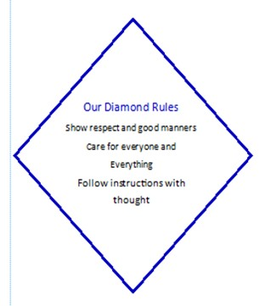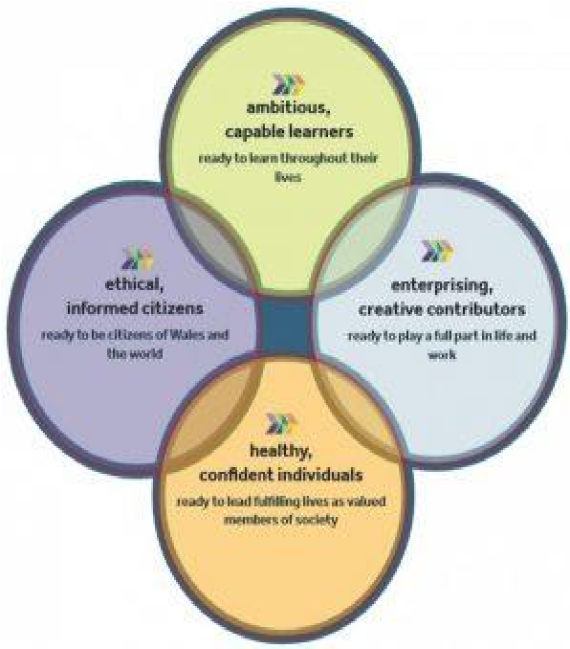  Our Four Core Purposes
  Our Instructions
  Listen to what other people say and show a welcoming response.
  To help each other and be kind.
  To reduce, reuse and recycle.
  To follow guidance from our teachers and to try our best.
Croeso! Welcome to Dosbarth Pedwar
Teacher: Mr Davies

Context for Learning:
Blue Abyss
Grab your wetsuit. We’re going deep into an underwater world of incredible coral and mysterious sea creatures. Can you pick a favourite fish, plant or animal? What do real divers get up to below the surface? Create a fishy story about exploring an amazing underwater world. Time to go a little deeper into our seas. Make a model deep sea submarine that can withstand great pressure and travel to the deepest, darkest places on Earth. Make sure you test it first. What are those bright lights in the distance? It’s a group of bioluminescent sea creatures. Look closely and create a colourful, 3-D art exhibition when you rise to the surface. Flippers on? Snorkel ready? Let’s head into the Blue Abyss.
We will aim to listen to each pupil reading individually and within Guided Group Reading during the week. Books will be changed during the week if we feel that the pupils are ready to move on. Pupils will also be allocated digital books and maths tasks on Active Learn. Diolch for your continued support.

During the Week:  PE on Monday and Wednesday. Kit to be worn to school. Most activities will be taken outdoors, weather permitting.  Weekly/ fortnight homework tasks set on Goggle Classroom and Active Learn. Personal spelling tasks will be allocated, if you wish to share your work with your teacher you can upload via Google Classroom. |  | We would like your help with:  Reading by updating their pupil reading record.  By accessing Reading Bugs and sharing the enjoyment of reading.  Completing homework tasks together.  By sharing personal achievements.

